**P273/1**

**GEOGRAPHY OF**

**EAST AFRICA**

**Paper 1**

**2:30 HOURS**

**ST JOHN’S HIGH SCHOOL KAWEMPE**

***Uganda Certificate for Lower Secondary Education {UCLSE}***

**S.2 – GEOGRAPHY PAPER 1**

**TIME: 2:30 HOURS**

**PART: I**

**MAP WORK PHOTOGRAPHIC INTERPRETATION, FIELD WORK**.

Answer FOUR questions from part II including question 1, 2 and 3 which are compulsory.

**SECTION: A**

**COMPULSORY QUESTION: MAPWORK (25 MARKS**)

Study the East Africa ***1:50,000*(UGANDA**) **LUKAYA** map extract part of sheet **79/2** series **Y732 2-USD** edition and answer questions that follow.

(a) (i) State the grid reference of the Antiquity at Lukaya. (01 mark)

(ii) Name the man made feature found at grid reference 697957 (01 mark)

(b) (i) State the bearing of a church at Kankobe (878938) from the borehole at 736916 (03 marks)

(ii) Identify the Hemisphere in which Lukaya is found. (02 marks)

(iii) Identify the Location of Lukaya . (02 marks)

(c) Draw a sketch map of the portion between Northing 88 and 98, and Easting 80 and 88 and on it mark

and name; (10 marks)

(i) contour 3800

(ii) the seasonal swamp

(iii) lake victoria

(iv) Linear Settlement.

(d) (i) Describe the relief of the Area shown on the map. (03 marks)

(ii) Identify any three economic activities taking place in the area. (03 marks)

2. **COMPULSORY PHOTOGRAPHIC INTERPRETATIONS. (25 marks)**

**Answer all parts of the Question.**

***Study the photograph provided below and answer the questions that follow.***

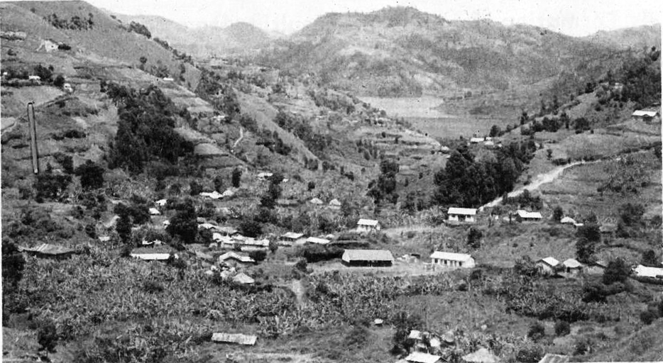

(a) Giving reasons for your answer identify the type of photograph. (02marks)

(b) Draw a landscape sketch of the area shown in the photograph and on it mark and name;

(i) two relief features

(ii) water body

(iii) three land-use types (06marks)

(c) Outline the problems faced by the people living in the area shown in the photograph. (05marks)

(d) Giving reasons for your answer, suggest an area in East Africa where the photograph could have been taken from. (02 marks)

**COMPULSORY FIELDWORK (25 MARKS)**

**For any one field work you have conducted**

3(a) (i) State the topic of the field work study. (02 marks)

(ii) Outline the objectives of the field work study. (05 marks)

(b) Outline the preparations you conducted before the study. (03 marks)

c) Draw a sketch map of the area studied during the field work and on it mark and label

(i) Physical features

(ii) Man-made features (07 marks)

(d) Describe how you used Two of the following methods during the study.

(i) Measurement

(ii) Sketching

(iii) Questionnaire

(iv) Use of existing documents. (04 marks)

(e) Explain how the fieldwork study enabled you to understand the geography of the area of study. (04marks)

**SECTION: B EAST AFRICA (25 MARKS)**

**Answer only one question from this part.**

4. (a) Differentiate between sedimentary rocks and metamorphic rocks. (04 marks)

(b) Describe the processes that led to the formation of sedimentary rocks in East

Africa. (06 marks)

(c) Explain the benefits of sedimentary rocks to the people of East Africa.

(08 marks)

(d) (i) Outline the problems faced by people living in areas with sedimentary

rocks. (05marks)

(ii) Name any two areas in East Africa with Sedimentary rocks. (02 marks)

5. (a) Draw a sketch map of East Africa and on it mark and name the following.

(i) Lakes: Magadi and George

(ii) Mountains: Rwenzori and Uluguru.

(iii) Rivers: Tana (08 marks)

(b) Describe the process that led to formation of Lake Tanganyika. (05 marks)

(c) Explain the benefits of Lakes to the people of East Africa. (06 marks)

(d) Outline the steps taken to solve the problems facing people living around lakes in

East Africa. (05 marks)

6. Study the table below showing the number of tourists into Kenya (1972-80) and answer the questions that follow.

|  |  |
| --- | --- |
| Year | Number of Tourists |
| 1972  1974  1976  1978  1980 | 350,000  380,000  430,000  450,000  470,000 |

***Source: Adapted from Waugh D. The World (P.120)***

(a)(i) Draw a line graph to show the information given in the table. (10 marks)

(ii) Describe the trend in the number of tourist as shown in the table and graph in

a(i) above. (03marks)

(b) Describe the factors which have attracted tourists to Kenya. (06marks)

(c) Explain the importance of tourist industry to Kenya. (04marks)

(d) Outline the problems facing the tourist industry in Kenya. (02marks)

7. Study figure 1: Sketch map of East provided and answer the questions that follow

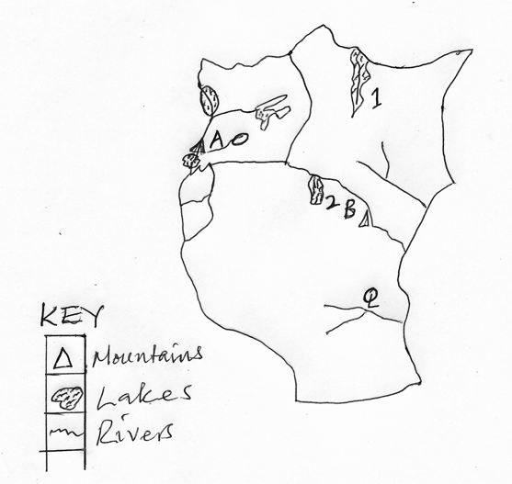

(a) Name the;

(i) lMountains marked A and B

(ii) Lakes 1 and 2

1. Rivers P and Q (07marks)

(b) Describe the process in the formation of river Deltas in East Africa. (05marks)

(c) Explain the benefits of river deltas to the people of East Africa (08marks)

(d) Outline the problems which are faced by the people living along river valleys in East Africa. (05marks)